

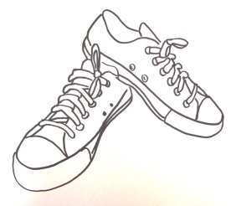**Louisiana Athletic Trainers’ Association invites you to support our shoe drive to “PAIR IT FORWARD”**

|  |  |
| --- | --- |
| **WHO:** | (enter your school/clinic/ATEP program etc) |
| **WHAT:** | A shoe drive collection for the charity ***Soles4Souls***. Please join us by cleaning out your closets and donating your new or gently worn shoes!! |
| **WHEN**: | March 1-31, 2015 |
| **WHERE**: | (Type Clinic name or school name/location here) |
| **WHY:** | To support Soles4Souls with their mission of “Wearing out Poverty” and to celebrate the 15th annual National Athletic Training Month. This year’s theme is “We Prepare-You Perform.” |
| **CONTACT:** | (Your name, Athletic Trainer) |





.

Louisiana Athletic Trainers’ Association. | “WE PREPARE-YOU PERFORM” | [lataprchair@gmail.com • www.latainc.org](mailto:lataprchair@gmail.com •  www.latainc.org)

**WE NEED YOUR OLD SHOES!!**

**Support the Louisiana Athletic Trainers’ Association by donating your old shoes to charity!**



Soles4Souls is a global not-for-profit institution dedicated to fighting the devastating impact and perpetuation of poverty. The organization advances its anti-poverty mission by collecting new and used shoes and clothes from individuals, schools, faith-based institutions, civic organizations and corporate partners, then distributing those shoes and clothes both via direct donations to people in need and by provisioning qualified micro-enterprise programs designed to create jobs in poor and disadvantaged communities. Based in Nashville, Tennessee, Soles4Souls is committed to the highest standards of operating and governance, and holds a four-star rating with Charity Navigator.

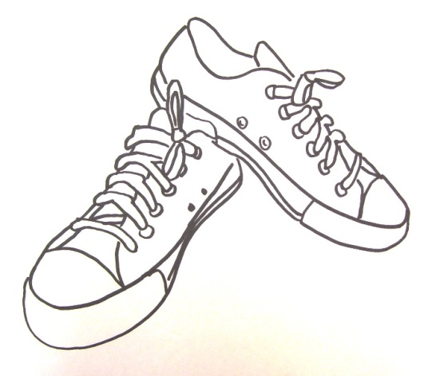

Louisiana Athletic Trainers’ Association. | “WE PREPARE-YOU PERFORM” | [lataprchair@gmail.com • www.latainc.org](mailto:lataprchair@gmail.com%20•%20%20www.latainc.org)

DONATE YOUR OLD SHOES TODAY!!!

*March, 2015-*The Louisiana Athletic Trainers’ Association will kick off National Athletic Training month by hosting a shoe drive. This year’s theme is “WE PREPARE-YOU PERFORM.” Athletic Trainers throughout the state of Louisiana will join the fight of “wearing out poverty” right along with the Soles4Souls organization! Shoes will be collected throughout the entire month of March. However, feel free to continue to drop them off at various locations until May 2015!



Louisiana Athletic Trainers’ Association.

“**WE PREPARE-YOU PERFORM**” [lataprchair@gmail.com • www.latainc.org](mailto:lataprchair@gmail.com%20%20•%20%20www.latainc.org)

[](https://images.search.yahoo.com/images/view;_ylt=AwrT6Vxa0etUJnEAEAYPxQt.;_ylu=X3oDMTB0MzkwOG5yBHNlYwNzYwRjb2xvA2dxMQR2dGlkA1lIUzAwNF8x?p=shoes+clip+art&back=https://search.yahoo.com/yhs/search?p%3Dclip%2Bart%2Bof%2Bshoes%26type%3DW3i_IA,206,0_01,DefaultSearch,20140207,19432,IE11,0,%26hsimp%3Dyhs-geneiotransfer%26hspart%3Dw3i%26ei%3DUTF-8&w=600&h=460&imgurl=www.clker.com/cliparts/2/b/8/c/11954239761336971637Machovka_Shoes.svg.hi.png&size=126KB&name=11954239761336971637Machovka_Shoes.svg.hi.png&rcurl=http://www.clker.com/clipart-9973.html&rurl=http://www.clker.com/clipart-9973.html&type=&no=6&tt=119&oid=a16052d66f540f87f516753926d77413&tit=clothing+shoes+sneakers+clip+art&sigr=11682d1ir&sigi=12ctrtse2&sign=11dl222lj&sigt=103d1h5lg&sigb=15ef0vdal&fr=yhs-w3i-geneiotransfer&hspart=w3i&hsimp=yhs-geneiotransfer)Soles4Souls is a global not-for-profit institution dedicated to fighting the devastating impact and perpetuation of poverty. The organization advances its anti-poverty mission by collecting new and used shoes and clothes from individuals, schools, faith-based institutions, civic organizations and corporate partners, then distributing those shoes and clothes both via direct donations to people in need and by provisioning qualified micro-enterprise programs designed to create jobs in poor and disadvantaged communities. Based in Nashville, Tennessee, Soles4Souls is committed to the highest standards of operating and governance, and holds a four-star rating with Charity Navigator.