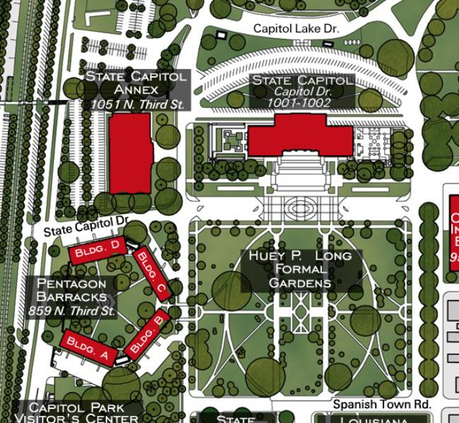

**We will meet at this corner of State Capitol Drive and N. 3rd Stree, next to the Pentagon at 12:30. We will then proceed to the Speaker Kleckley's apartment for a meeting.**

**Parking**